Lab Report - Practicing Windows Interface

# Aim

To learn how to navigate and use key elements of the Windows interface, including the Start menu, taskbar, title bar, Windows Help, My Computer, and Recycle Bin.

# Requirements

- A computer running the Windows operating system

- Basic understanding of using a computer

# Procedure / Steps

## Part 1: Using the Start Menu

1. Click the "Start" button at the bottom-left or center of the screen.

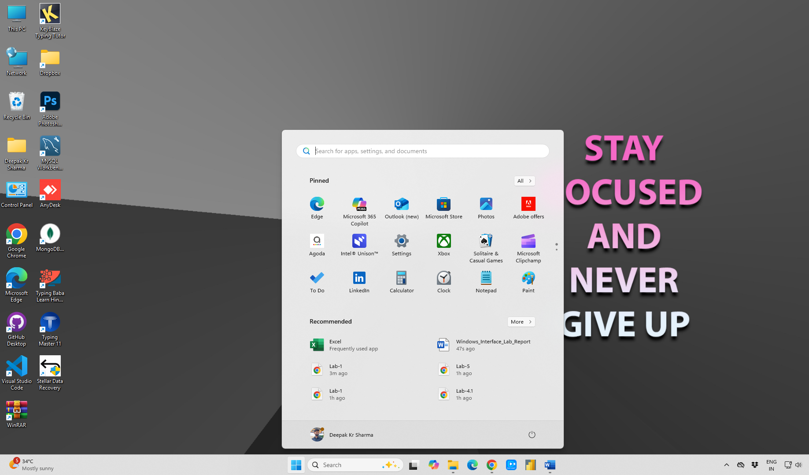

2. Explore the menu to find apps, documents, and settings.

3. Click on an application like Notepad or Microsoft Word to open it.

## Part 2: Using the Taskbar

1. The taskbar shows open apps and system notifications at the bottom of the screen.

2. Right-click an app in the Start Menu and select "Pin to taskbar".

3. Click icons to switch apps or hover for previews.

## Part 3: Using the Title Bar

1. The title bar is at the top of a window, showing the name of the app or document.

2. Use the minimize, maximize, and close buttons.

## Part 4: Using Windows Help

1. Press F1 or search "Help" in the Start Menu.

2. Search for help topics using keywords.

## Part 5: Using My Computer (This PC)

1. Double-click "This PC" on the desktop or access it from Start Menu.

2. Explore drives and folders to manage files.

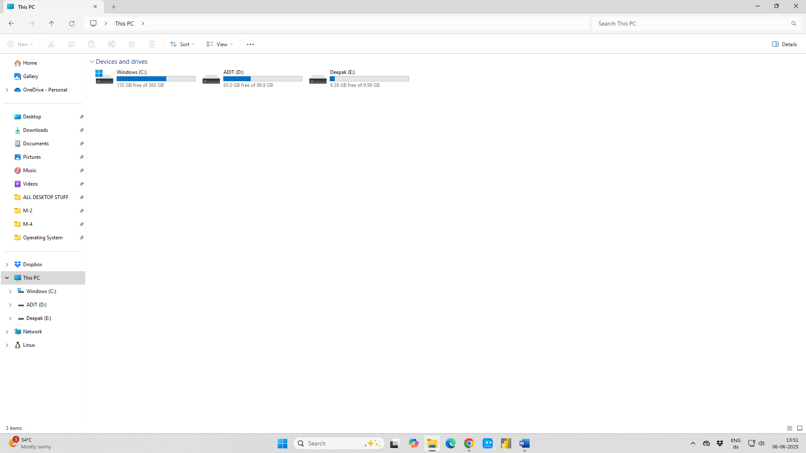

## Part 6: Using the Recycle Bin

1. Double-click the "Recycle Bin" on the desktop.

2. Right-click to restore or permanently delete files.

# Conclusion

By familiarizing yourself with key Windows elements such as the Start menu, taskbar, title bar, Windows Help, My Computer, and Recycle Bin, you can use the Windows interface more efficiently and increase your productivity.